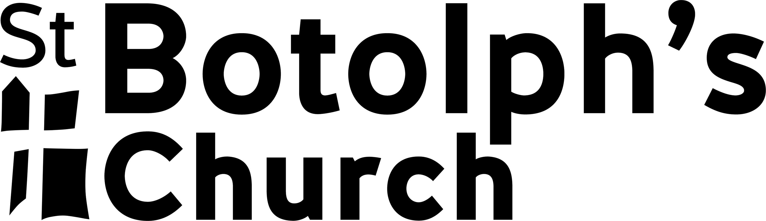

*May we have your permission to give your child over-the-counter painkillers (e.g. Paracetamol) in the event of headaches etc?*

YES NO

*In order to get to Nottingham we need to travel by car. Please may we have your permission for them to travel in one of our leaders or parents private cars? Driver will be aged 21 or older. YES NO*

*Will your child be bringing any prescription medication with him/her*?  
*If “Yes”, please provide us full details here - and tell us if and how you would like us to look after/administer it YES NO*

*Does the child suffer from any medical conditions of which we should be aware?  
If “Yes”, please provide us full details here. PLEASE INCLUDE ANY SPECIFIC DIETARY REQUIREMENTS. YES NO*

**1. Details & Emergency Contacts**

*If you are already over 18, then complete this section yourself (references to “my child/ward” will be understood as referring to yourself.) If you are not yet 18 your parent/guardian must sign.*

I certify that the information given above is accurate to the best of my knowledge and belief.

I understand that emergency situations can and do occasionally arise. In the unlikely event of there being one involving my child/ward, and if the leaders are unable to first make timely contact with me, then I give my consent for him/her to receive whatever medical treatment the emergency/medical services deem necessary, including but not limited to the administration of anaesthetics.

date

*Name & Signature of parent/guardian*

name of child attending

*Please give us at least two emergency contact details*

date of birth

Emergency Contact 1

Emergency Contact 2

Name:

Relationship:

Tel:

Name:

Relationship:

Tel:

Medical/Consent Form

Midlands Youth Convention 2019

1. *to be completed by Parent/Guardian*
2. *Please complete in BLOCK CAPITALS*

**2. Your Consent**